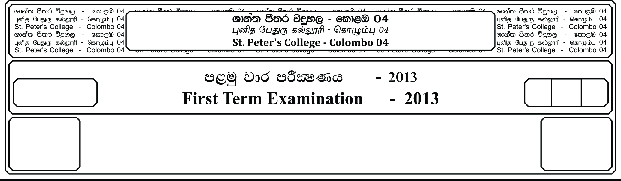

meh 01

01 hours

**m<uq jdr mßlaIKh - 2019**

**First Term Examination- - 2019**

E

12 fY%aKsh

GRADE 12

I

25/07/2019

cSj úoHdj - II

**Biology - II**

**Part A – Structured Essay**

✶ Answer all questions on this paper itself.

01. A). i. What is meant by adaptation?

**__________________________________________________________________________________**

**__________________________________________________________________________________**

**__________________________________________________________________________________**

ii. State 02 structured adaption in xerophytic plants.

**__________________________________________________________________________________**

**__________________________________________________________________________________**

iii. State the structural components of following compounds.

a. RuBP - ___________________________________________________________________

b. ATP - ___________________________________________________________________

c. Phospholipid - ___________________________________________________________________

iv. State 3 main functions of ami